­NEWS RELEASE

April XX, 2020

**Stirnimann debuts three Potain Hup C 40-30 cranes on Swiss railway project**

* *The project is the first that the innovative crawler mounted Hup C 40-30 self-erecting cranes have been used on.*
* *The compact dimensions of the Hup C 40-30 mean ease-of-transportation and increased access, and the crawler tracks make it mobile when erected.*

The first Potain Hup C 40-30 crawler mounted self-erecting cranes have been deployed on a job site in Switzerland.

Construction equipment supplier and longstanding customer Stirnimann AG has supplied three cranes to contractor Implenia for the construction of a 1.2 km rail flyover at Renens VD station, close to Lausanne.

The flyover will allow trains to pass over existing railway tracks, helping to improve efficiency and convenience for passengers. The cranes are working around the clock, as the flyover is planned for completion in December 2021.

The Hup C 40-30 was launched at bauma 2019 and is unique to Potain’s self-erecting tower crane line, as it is the first crane to be enhanced with crawler tracks for ultimate mobility on job sites with challenging terrain.

The crane was developed side-by-side with Stirnimann AG as part of Manitowoc’s Voice of the Customer program. Stirnimann, based in Olten, Switzerland, was the Hup C 40-30’s first buyer, purchasing six of the unique crawler self-erecting cranes. Half of these cranes are now being used on the Renens VD project.

**Perfect for job sites with limited workspace and tough terrain**

The Hup C 40-30 impressed contractor Implenia with its ease-of-transportation, fast and simple erection, and versatility and mobility on the job site.

The special application crane boasts a compact transport length of 13.5 m and a width of 2.55 m. With its embedded power generator, it can also travel and erect by itself. When folded, the crane can travel at 25 m/min and features front levelling up to 30 percent and side levelling up to 12 percent.

During the erection process, the crane is hydraulically leveled and has a footprint of 5m x 4.5m. Once erected, the crane exhibits up to 5 percent front and side levelling. It can also be repositioned while fully erected and travels at a speed of 10 m/min. This is a big advantage as the cranes have to be repositioned alongside the bridge every two weeks.

“The self-erecting Potain Hup C 40-30 is a truly innovative concept — it’s the first crane to be enhanced with crawler tracks for ultimate mobility,” said Fritz Oschwald, managing director of Stirnimann. “To build the rail flyover in Renens, Implenia has rented three Hup C 40-30 cranes for ten months. The feedback we have received so far is very positive. Thanks to the mobility of the crane on the job site, our client is able to get to work efficiently and make good progress.”

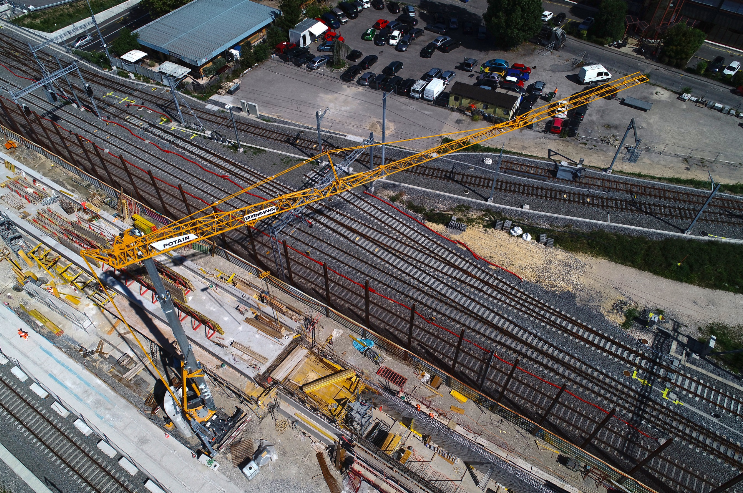

-END-

CONTACT

**Cristelle Lacourt**

Manitowoc

T +33 472 182 018

cristelle.lacourt@manitowoc.com

ABOUT THE MANITOWOC COMPANY, INC.

The Manitowoc Company, Inc. (“Manitowoc”) was founded in 1902 and has over a 117-year tradition of providing high-quality, customer-focused products and support services to its markets and its 2019 net sales were approximately $1.83 billion. Manitowoc is one of the world's leading providers of engineered lifting solutions. Manitowoc, through its wholly-owned subsidiaries, designs, manufactures, markets, and supports comprehensive product lines of mobile telescopic cranes, tower cranes, lattice-boom crawler cranes, and boom trucks under the Grove, Manitowoc, National Crane, Potain, Shuttlelift and Manitowoc Crane Care brand names.

THE MANITOWOC COMPANY, INC.

One Park Plaza – 11270 West Park Place – Suite 1000 – Milwaukee, WI 53224, USA

T +1 414 760 4600

[**www.manitowoc.com**](http://www.manitowoc.com)**­**